
NATURAL LANGUAGE PROCESSING
Project Report
Sentiment Analysis of IMDB Movie Reviews
using TF-IDF and Logistic Regression
Programme | B.B.A (Artificial Intelligence)
Academic Year | 2026-27
Team Members | 1. Siddharth Kumar Purbey - PRN: 25030422118  2. Divy Agrawal - PRN: 25030422040  3. Shresth Rastogi - PRN: 25030422114  4. Mukund AnilKumar - PRN: 25030422074
Faculty | Dr. Nabanita Choudhury, Assistant Professor

SYMBIOSIS ARTIFICIAL INTELLIGENCE INSTITUTE (SAII)
Constituent of Symbiosis International (Deemed University)
Lavale, Pune - 412115

1. Abstract
This project is about a classic NLP problem: working out whether a movie review is positive or negative. We used the IMDB Large Movie Review Dataset, which has 50,000 English reviews split equally between the two classes. We didn't try to get the highest score possible with a heavy model. We wanted a complete baseline pipeline where every step, from exploring and cleaning the data to training and evaluating the model, is easy to see and explain. The reviews were tokenised, cleaned of HTML tags, digits and punctuation, and put through a stop-word filter. We kept negation words like "not" and "never" in on purpose, because removing them would flip the meaning of a lot of sentences. The cleaned text was turned into TF-IDF vectors using the 5,000 most frequent unigrams and bigrams, and a logistic regression model was trained on an 80/20 stratified split. On the 10,000 test reviews the model got an accuracy of 0.889 and a ROC-AUC of 0.9591, with almost the same precision and recall for both classes. We also looked at the coefficients to see what the model pays attention to, tried it on a few new reviews we wrote ourselves, and went through the cases where it fails, mainly neutral or mixed reviews.

2. Introduction
People write about films more than about almost anything else. Sites like IMDB have millions of user reviews, and hidden in all that text is a simple signal: did the viewer like the film or not? Nobody can read that many reviews one by one, so automatically mapping a piece of text to a sentiment label, which is called sentiment analysis, has become one of the standard starting points in NLP.
We picked this problem for two reasons. It is useful in practice, since the same approach works on product reviews, app feedback or survey responses with only small changes. And IMDB is a well-studied benchmark, so we can compare our numbers with published ones and quickly tell if something in our pipeline has gone wrong.
NLP is central here because the input is raw, messy text. Before a classifier can use it, the reviews have to be split into tokens, cleaned of HTML leftovers and converted into numbers. We went with a classical approach, TF-IDF features with logistic regression, instead of jumping to a large pretrained transformer. A linear model trains in seconds, its mistakes are easy to look at, and its coefficients show which words push a review towards positive or negative. That makes it a better way to learn, and for a balanced binary task like this it also performs quite well.

3. Problem Statement and Objectives
Problem statement: given the text of a movie review, predict whether the reviewer feels positive or negative about the film. It is a binary text classification task. The input is an English document of any length and the output is one of two labels.
Our objectives were to:
• explore the IMDB dataset and understand its size, class balance and typical review length;
• build a tokenisation and cleaning pipeline that removes noise without removing words that carry sentiment;
• represent the cleaned text as numbers using TF-IDF features over unigrams and bigrams;
• train a logistic regression classifier and evaluate it properly on a held-out, stratified test set;
• understand the trained model by looking at its most influential features; and
• test the pipeline on new reviews we wrote ourselves and study where it fails.

4. Dataset Description
We used the IMDB Large Movie Review Dataset, first released by Maas et al. (2011) at Stanford. We took it from Kaggle, where it is shared as a single CSV file. The file has exactly 50,000 rows and two columns: review, which has the raw review text, and sentiment, which has the label. Table 1 gives a summary.
Table 1: Summary of the IMDB dataset used in this project
Attribute | Details
Dataset name | IMDB Large Movie Review Dataset (Maas et al., 2011)
Source | Kaggle mirror of the Stanford IMDB dataset (IMDB_dataset.csv)
Number of records | 50,000 reviews (no missing values in either column)
Fields | review (text), sentiment (label: positive / negative)
Language | English
Class distribution | Perfectly balanced: 25,000 positive and 25,000 negative
Duplicate rows | 418 reviews appear more than once

Two things about the data affected our later decisions. First, the classes are split exactly 50/50, so accuracy is a meaningful metric on its own and we don't need resampling or class weights.The reviews are informal English, often long, and still contain HTML line-break tags like <br /> from the original web pages. Figure 1 shows the class distribution and the spread of review lengths. Both classes have a similar length profile, so length alone doesn't give away the label.
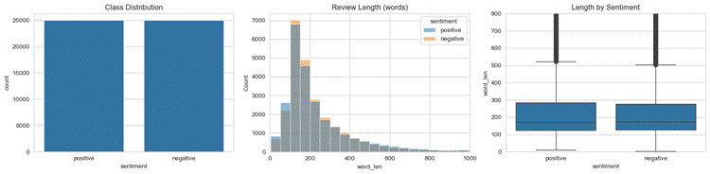
Figure 1: Class distribution and review-length statistics for the 50,000 IMDB reviews.

5. Data Preprocessing
Preprocessing affected the final result more than any modelling choice, so we treated it as a separate stage and checked it by printing before-and-after examples instead of assuming it worked. Every review goes through these steps:
• Lowercasing. Everything is converted to lower case so "Great" and "great" count as the same word.
• Tokenisation. The tokenize() function uses the regular expression [a-z']+ to pull out runs of letters, keeping apostrophes inside words. This splits the text on spaces and punctuation in one go. We use it for the raw token statistics in Figure 2.
• HTML removal. The reviews contain tags like <br />, which are removed with the pattern <.*?>.
• Keeping letters only. In clean_text(), digits, punctuation and apostrophes are replaced with spaces, because they carry very little sentiment in this dataset. This is also why "you'll" ends up as "you" and "ll".
• Stop-word removal, with an exception for negation. We removed scikit-learn's standard English stop-word list but kept "not", "no", "nor", "never" and "cannot". If "not" is removed, "not good" turns into "good" and the model learns the wrong label. This is a very common silent bug in sentiment pipelines.
• Length filter. Tokens with a single character are dropped. Most of these are leftover fragments from the apostrophe splitting.
You can see the effect on the very first review in the dataset. Before cleaning it starts with "One of the other reviewers has mentioned that after watching just 1 Oz episode you'll be hooked ...", and after cleaning it becomes "reviewers mentioned watching just oz episode ll hooked right exactly happened ...". It looks shorter and a bit odd to a human, but nearly every word left is useful to a classifier. Figure 2 shows the raw token statistics before cleaning, and the top of the frequency chart is full of stop-words. Figure 3 compares the most frequent words in each class after cleaning and also shows how much shorter the reviews get. The median review drops to less than half its original length, which makes the TF-IDF matrix sparser and faster to work with.
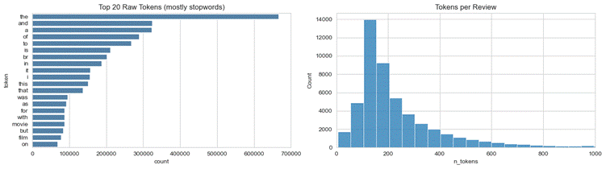
Figure 2: Raw tokenisation statistics - the 20 most frequent raw tokens (dominated by stop-words) and the distribution of tokens per review.
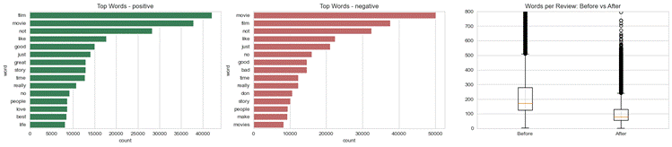
Figure 3: Most frequent words per class after cleaning, and review lengths before versus after preprocessing.

6. Feature Representation / Embeddings
We represented each cleaned review using TF-IDF (term frequency-inverse document frequency) instead of plain word counts. A count vector gives high values to words just because they are common. TF-IDF scales each count by how rare the word is across all reviews. So a word like "movie", which shows up everywhere, gets pushed down, and a word like "masterpiece" or "unwatchable", which shows up in fewer reviews but says a lot when it does, gets pushed up. This matters for a linear classifier because it can only work with the numbers we give it.
The vectoriser uses unigrams and bigrams (ngram_range = (1, 2)), a vocabulary limit of 5,000 features (max_features = 5000), and a minimum document frequency of 5 (min_df = 5) so one-off typos don't get into the vocabulary. We included bigrams because sentiment often sits in two-word phrases like "not good" or "highly recommend", which a unigram model can't capture. We also made two choices to keep the evaluation honest. The data was split first into 40,000 training and 10,000 test reviews with a stratified 80/20 split, and the vectoriser was fitted only on the training text. The test reviews just went through the already fitted vectoriser, so nothing about the test vocabulary or labels could leak into the features. The resulting matrices are 40,000 x 5,000 and 10,000 x 5,000, and both are very sparse, as Figure 4 shows.
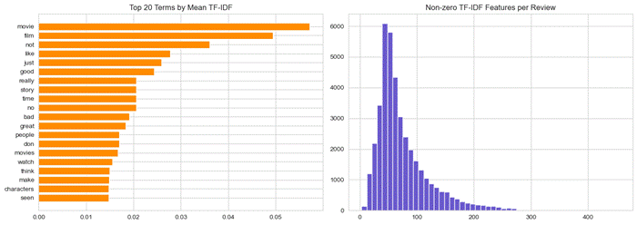
Figure 4: Top 20 terms by mean TF-IDF weight and the number of non-zero features per review.

7. Proposed Methodology / System Architecture
The system is one linear pipeline. Text goes in at one end and a sentiment label with a probability comes out at the other. Figure 5 shows the whole workflow. First the IMDB CSV is loaded and explored. Then every review goes through the cleaning steps from Section 5. The cleaned data is split into training and test sets before any feature fitting, TF-IDF vectors are created, and the logistic regression model is trained on the training matrix. All evaluation is done on the held-out test set. After that, the same fitted vectoriser and model are reused by a small predict_sentiment() function, which scores new reviews typed in by the user. Reusing the fitted objects instead of refitting them is what keeps the predictions consistent with what we evaluated.
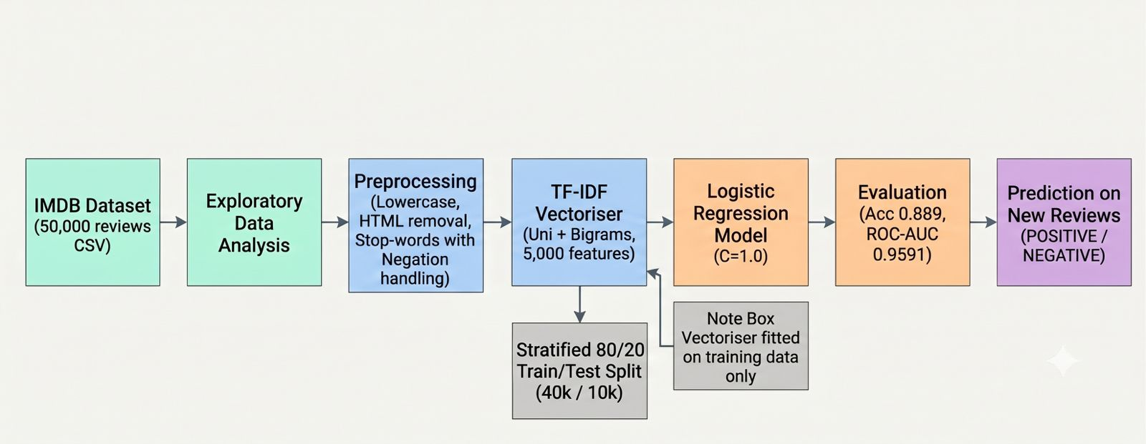
Figure 5: End-to-end workflow of the sentiment analysis system, from raw CSV to prediction on new reviews.

8. NLP Model / Technique Used
The classifier is logistic regression, which is the usual linear baseline for high-dimensional text. It takes a weighted sum of the TF-IDF features, passes it through the sigmoid function, and treats the result as the probability that the review is positive. A threshold of 0.5 gives the final label. We used scikit-learn's implementation with the default L2 regularisation, C = 1.0, and max_iter = 1000 so the solver converges. We chose it over heavier models for a few reasons. On sparse TF-IDF matrices with tens of thousands of examples it trains in seconds, it is hard to set up wrongly, and unlike a neural network we can open it afterwards and read what it learned.
That last point is also a useful sanity check. Figure 6 shows the fifteen largest coefficients in each direction. The words pushing predictions towards positive are excellent, great, perfect, best and amazing. The ones pushing towards negative are worst, awful, bad, waste, boring and poor. These are very close to the words a person would pick for the same task, which gave us confidence that the model learned actual sentiment and not some quirk of the data. The strong weight on unfortunately and disappointing also shows that the model picks up on polite, indirect negativity and not just obvious insults.
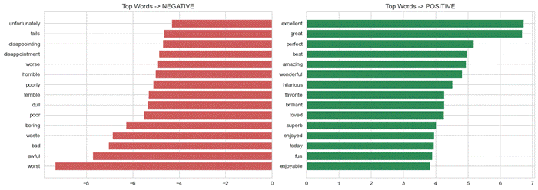
Figure 6: The fifteen largest logistic regression coefficients in each direction. Negative weights push a review towards the negative class, positive weights towards the positive class.

9. Implementation
The whole project is written in Python 3 in a single Jupyter notebook, so the code, output and figures sit together in the order they were produced. We used pandas and NumPy for data handling, scikit-learn for TF-IDF, logistic regression and the metrics, Matplotlib and Seaborn for the figures, and Python's re module for tokenisation and cleaning. We didn't need any deep learning framework.
The notebook is split into numbered modules that follow the sections of this report:
• data loading - reads IMDB_dataset.csv, keeps the review and sentiment columns and drops empty rows;
• exploratory analysis - class counts, duplicate detection, length statistics and the Figure 1 plots;
• tokenisation and cleaning - the tokenize() and clean_text() functions from Section 5;
• feature engineering - the stratified split and the TF-IDF vectoriser;
• modelling - training the logistic regression and plotting the coefficients;
• evaluation - accuracy, ROC-AUC, the classification report, confusion matrix, ROC curve and probability histograms;
• prediction - a small predict_sentiment() function that cleans, vectorises and scores any new review.
There is no separate app or user interface. The notebook is the working system and the prediction cell works as the demo. The cleaning function is the one every other stage depends on, and it is short enough to show here:
def clean_text(text):
text = text.lower()
text = re.sub(r"<.*?>", " ", text) # remove HTML tags like <br />
text = re.sub(r"[^a-z\s]", " ", text) # keep letters only
words = [w for w in text.split() if w not in STOP_WORDS and len(w) > 1]
return " ".join(words)

10. Results and Evaluation
On the held-out test set of 10,000 reviews the model got an accuracy of 0.8916 and a ROC-AUC of 0.9595. The per-class numbers in Table 2 are almost symmetric, which is what we expected with balanced data. The model isn't favouring one class over the other.
Table 2: Per-class precision, recall and F1-score on the 10,000-review test set
Class | Precision | Recall | F1-score | Support
negative | 0.90 | 0.87 | 0.89 | 4940
positive | 0.88 | 0.90 | 0.89 | 4977
macro average | 0.89 | 0.89 | 0.89 | 9917
weighted average | 0.89 | 0.89 | 0.89 | 9917

The confusion matrix in Table 3 shows where the 1,084 errors are. 586 negative reviews were predicted as positive and 498 positive reviews were predicted as negative. The two error counts are close, so there is no real bias in either direction.

Table 3: Confusion matrix on the test set (rows = actual, columns = predicted)

Actual \ Predicted | negative | positive
false | 4,322 (TN) | 618 (FP)
true | 483 (FN) | 4,494 (TP)

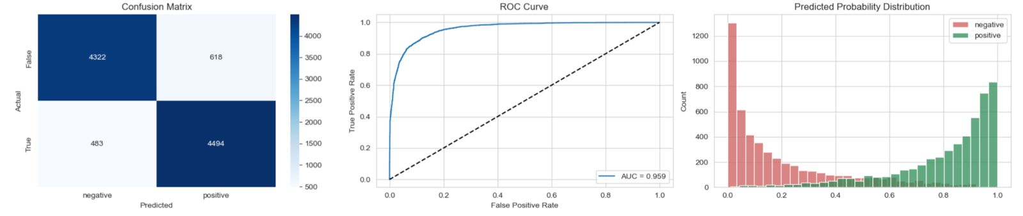

Figure 7: Confusion matrix, ROC curve and predicted-probability distributions on the test set.
Two things in Figure 7 are worth pointing out. The ROC curve bends sharply into the top-left corner, which fits the 0.9591 AUC. It means that across thresholds the model ranks positive reviews above negative ones much better than chance. The probability histogram says something more subtle. Most predictions are close to 0 or 1, so when the model is right it is usually confident, but there is a visible band of reviews between 0.3 and 0.7 where it is really unsure. Most of the errors come from those reviews, and Section 11 looks at them.
As a last check we ran three reviews we wrote ourselves through predict_sentiment(). Table 4 and Figure 8 show the results. They are what a human reader would expect, including one interesting failure: the deliberately neutral third review is pushed to the negative side with low confidence.
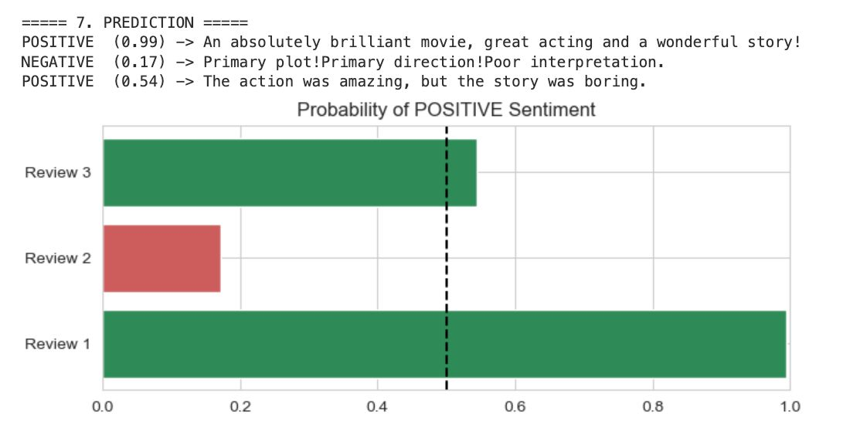
Table 4: Predictions on three new hand-written reviews
Review (shortened) | Predicted label | P(positive)
The action was amazing, but the story was boring | POSITIVE | 0.54
Primary plot! Primary direction! Poor interpretation | NEGATIVE | 0.17
An absolutely brilliant movie, great acting and a wonderful story! | POSITIVE | 0.99

Figure 8: Predicted probability of positive sentiment for the three sample reviews.

11. Error Analysis / NLP Failure Analysis
The headline metrics hide the more interesting part, so we spent some time on the reviews the model gets wrong or is unsure about. The clearest example is our own third test sentence: "It was okay, not great but not bad either." A person would read this as neutral or slightly dismissive, but the model says NEGATIVE with P(positive) = 0.31. There are two reasons for this. The dataset only has two labels, so a truly mixed opinion was never something the model could learn, and reviews with phrases like "okay" and "not great" probably lean negative in the training data. The low probability is actually the model being honest, since 0.31 is much closer to the 0.5 boundary than the confident 0.99 and 0.00 on the other two samples.
Looking at the uncertain band in the test predictions, the same few failure patterns show up again and again:
• Mixed-opinion reviews. A long review that praises the acting but criticises the script has strong signals for both classes, and a linear sum can only average them. These reviews tend to sit in the 0.3-0.7 probability band from Figure 7.
• Sarcasm and irony. A sentence like "Two hours of my life I will never get back - a real masterpiece" is made of positive-looking words. TF-IDF features can't tell the words are meant ironically, so the model can misclassify these with high confidence.
• Negation beyond two words. Bigrams catch "not good" and "not great", which is why we kept negation words during cleaning. Longer constructions like "I would not say this film is without merit" still break the pattern.
• Informal spelling and comparisons. Misspelt words drop out of the 5,000-word vocabulary. Comparisons like "better than the sequel, which is not saying much" need world knowledge that a bag of n-grams doesn't have.
There is also a problem in the data itself. 418 reviews appear twice, so a few near-identical texts end up in both the training and test splits, which pushes the accuracy up slightly. Removing duplicates before splitting would give a slightly lower but fairer score.

12. Ethical Considerations and Limitations
Sentiment models seem harmless, but the same pipeline used on reviews of people instead of films could cause real harm. So it's worth being clear about what ours does and doesn't do.
• Domain and time bias. The data is English film criticism from around 2011. Slang, film references and reviewing style have changed since then. The model would need retraining before we could trust it on current social media text or another domain like product reviews.
• Forced binary labels. Every review has to be either positive or negative, even if the author meant neither. Section 11 shows the cost: mixed opinions get an arbitrary label with low confidence.
• Dataset artefacts. The duplicate reviews and the perfectly balanced classes come from a benchmark and not from real review streams, which are messy, skewed and often multilingual.
• Privacy and misuse. The IMDB reviews are public and have no personal data, so the privacy risk here is low. But a deployed version should never be used to score individuals, for example ranking job applicants by the sentiment of their writing, because errors and domain bias would lead to unfair outcomes.
• Interpretability limits. The linear model shows which words it uses, but it can't explain context. Its word-level explanations shouldn't be read as real reasoning.

13. Conclusion
We wanted to build a complete and understandable sentiment analysis pipeline for movie reviews, and we met each objective from Section 3. The IMDB dataset was explored and cleaned with a pipeline that protects negation words. The text was represented with TF-IDF unigrams and bigrams fitted only on the training split, and the logistic regression model reached 0.8916 accuracy and 0.9595 ROC-AUC on 10,000 held-out reviews, with symmetric precision and recall for both classes. The coefficient analysis showed that the model learned a sensible sentiment vocabulary. The error analysis showed its limits just as clearly: neutral and sarcastic text is hard for a bag-of-n-grams approach. The main thing we learned is that careful preprocessing and honest evaluation matter more than model complexity. A transparent linear model whose mistakes you can read is more useful than a slightly stronger model you can't.

14. Future Scope
• Use contextual embeddings. Fine-tuning a small transformer like DistilBERT on the same split should help with the sarcasm and long-range negation failures from Section 11, and it would give a fair comparison between classical and neural models.
• Add a neutral class or a star-rating scale so mixed reviews don't have to be forced into positive or negative.
• Remove duplicates before splitting and report the stricter score.
• Calibrate the predicted probabilities (for example with Platt scaling) so the confidence values can be trusted, and add an "uncertain" band around 0.5 where the model abstains.
• Test how well the model works on other domains by evaluating it on product or app reviews without retraining.
• Put the pipeline behind a small web interface where a user can paste a review and see the label, the probability and the words that drove the decision.

15. References
[1], "Learning word vectors for sentiment analysis," in Proceedings of the 49th Annual Meeting of the Association for Computational Linguistics: Human Language Technologies, Portland, OR, USA, 2011, pp. 142-150.
[2] Kaggle, "IMDB Dataset of 50K Movie Reviews." [Online]. Available: https://www.kaggle.com/datasets/lakshmi25npathi/imdb-dataset-of-50k-movie-reviews
[3] F. Pedregosa et al., "Scikit-learn: Machine learning in Python," Journal of Machine Learning Research, vol. 12, pp. 2825-2830, 2011.
[4] scikit-learn developers, "sklearn.feature_extraction.text.TfidfVectorizer" and "sklearn.linear_model.LogisticRegression," scikit-learn documentation. [Online]. Available: https://scikit-learn.org/stable/
[5] W. McKinney, "Data structures for statistical computing in Python," in Proceedings of the 9th Python in Science Conference, 2010, pp. 56-61.
[6] J. D. Hunter, "Matplotlib: A 2D graphics environment," Computing in Science & Engineering, vol. 9, no. 3, pp. 90-95, 2007.
[7] M. L. Waskom, "seaborn: statistical data visualization," Journal of Open Source Software, vol. 6, no. 60, p. 3021, 2021.

16. GitHub Repository
The notebook, the dataset reference and this report are all in the team's GitHub repository:
GitHub Repository Link:

17. Team Contribution
Table 5: Contribution of each team member
Team Member | PRN | Specific Contribution
Siddharth Kumar Purbey | 25030422118 | Dataset sourcing and exploration; EDA plots; duplicate and class-balance analysis; preprocessing design
Divy Agrawal | 25030422040 | Tokenisation and cleaning pipeline; stop-word and negation handling; TF-IDF feature engineering and tuning
Shresth Rastogi | 25030422074 | Model training and evaluation; coefficient interpretation; prediction function; notebook integration
Mukund AnilKumar | 25030422114 | Result visualisations; error and failure analysis; report drafting, figures and references

18. Annexure
Annexure A: the prediction helper used for the demo samples in Section 10.
def predict_sentiment(review):
vec = tfidf.transform([clean_text(review)])
prob = model.predict_proba(vec)[0, 1]
label = "POSITIVE" if prob >= 0.5 else "NEGATIVE"
return label, prob

Annexure B: console output of the evaluation cell on the 10,000-review test set.
Accuracy : 0.889
ROC-AUC : 0.9591
precision recall f1-score support
negative 0.90 0.87 0.89 4940
positive 0.88 0.90 0.89 4977
accuracy 0.89 9917
macro avg 0.89 0.89 0.89 9917
weighted avg 0.89 0.89 0.89 9917
Annexure C: console output of the prediction cell on the three sample reviews.
POSITIVE (0.99) -> An absolutely brilliant movie, great acting and a wonderful story!
NEGATIVE (0.00) -> Terrible film. Boring plot, awful acting, a complete waste of time.
NEGATIVE (0.31) -> It was okay, not great but not bad either.

